BACH’S MASS IN Goldberg

Music from The Goldberg Variations by Johann Sebastian Bach

Thirty Two Settings From The Traditional (Tridentine) Latin Mass

Arranged by Ed Kotski

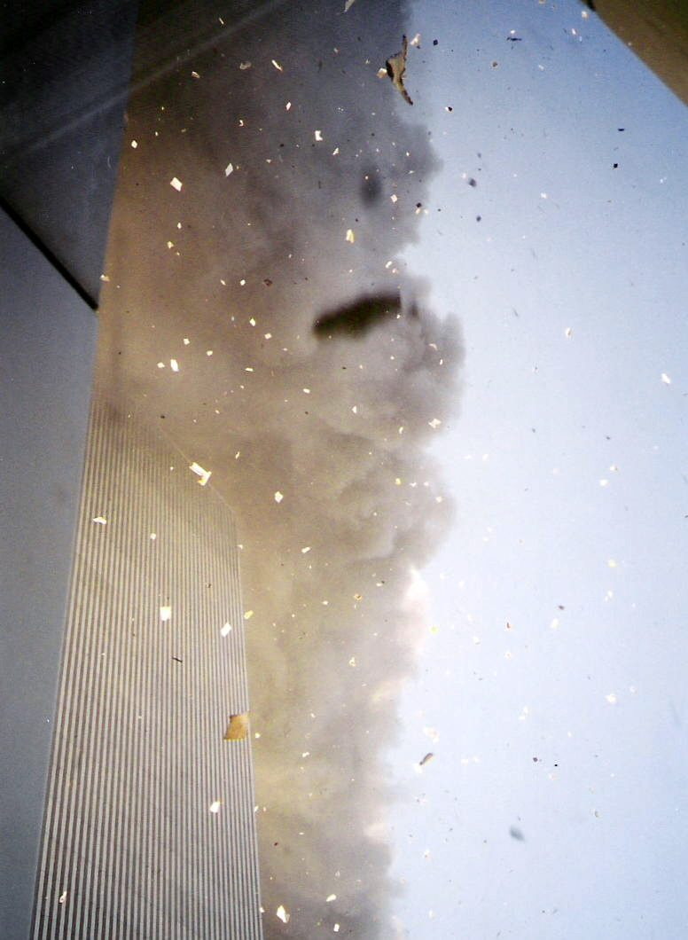

View From WTC 1, Looking South

Copyright 2001, 2002, 2003 by Ed Kotski

All Rights Reserved

From JSBachfoa.org

Thanks for using our site. We hope you find this material useful and enjoyable.

Here are a few of the Subjects and Articles you can find at JSBachfoa.org

Photographs and Personal experience with the attack on the World Trade Center, September 11, 2011

Articles about J S Bach including:
1. How he wrote his music (disclosed for the first time ever)
2. The relationship between Bach's Music and the attacks
3. Examples of Bach's keyboard music, as he heard it
4. Sheet Music

Beethoven, too (What's he doing here?)

Literary and Historical Articles including:
1. How Joyce Kilmer came up with "Trees" (and you aren't going to guess)

Fire Fighting and Emergency Medical Services:
1. Calculating friction loss, flow, and nozzle reaction in the fire service
2. Solving Water Flow problems using Electric Circuit Theory
3. A simple way to predict the flow from a centrifugal pump
2. A graph of the Henderson - Hasselbalch Equation

Latin:
1. How to Read It and How to Write It using a unique "Color Coded" approach
2. How to Speak It

And More.

DISCLAIMER AND LICENSE
Our goal is to provide accurate and useful information, but everything is offered "as is".
It is up to the user to verify that the information is accurate and suitable for the user's
purpose. We can not and will not, to the extent allowed by law, accept liability for any damage caused by our products. Users should should check all for viruses and in addition, especially for executables, try them out in an environment where they won't do any harm if they don't function properly. Some files have instructions - read them.

This website and its contents are copyrighted and all rights are reserved, except that permission is given to download a single copy of material which is expressly offered to the public, but this permission does not include the rights to sell, transmit, or otherwise disseminate such material, nor does it include any rights to the site's design or code.

